Unit 4
A1.1.2 Linear Equations
A1.1.2.1 Write, solve, and/or graph linear equations using various methods.
A1.1.2.1.1 Write, Solve, and/or apply linear equations (including problem situations).
A1.1.2.1.2 Use and/or identify an algebraic property to justify any step in an equation-solving process
A1.1.2.1.3 Interpret solution to problems in the context of the problem situation

A1.2.1 Functions
A1.2.1.2 Interpret and/or use linear functions and their equations, graphs, or tables
A1.2.1.2.1 Create, interpret, and/or use the equation, graph, or table of a linear function
A1.2.1.2.2 Translate from one representation of a linear function to another (i.e., graph, table, and equation)

A1.2.2 Coordinate Geometry
Anchor Descriptor/Eligible content
A1.2.2.1 Describe, compute, and/or use the rate of change (slope) of a line
A1.2.2.1.1 Identify, describe, and/or use constant rates of change.
A1.2.2.1.2 Apply the concept of linear rate of change (slope) to solve problems
A1.2.2.1.3 Write or identify a linear equation when given
- The graph of the line,
- Two points on the line, or
- The slope and a point on the line
Note: Linear equation may be in point-slope, standard, and/or slope-intercept form
A1.2.2.1.4 Determine the slope and/or interpret data on a scatter plot
A1.2.2.2 Analyze and/or interpret data on a scatter plot.
A1.2.2.2.1 Draw, identify, find, and/or write an equation for a line of best fit for a scatter plot

Patterns and Functions;
Linear Patterns
- The total number of hours that Kane had practice piano at the end of each of the past six weeks is shown below.
2, 5, 8, 11, 14, 17
Her total hours follow a pattern. Which expression can be used to predict the total number of hours she will have practiced at the end of n weeks?
- 2n + 1
- 2n – 18
- 3n – 1
- 3n + 1
Tables
- The table shows the 2008 United States first-class postage rate, d(w) for packages of maximum weight, w
Postage Rate for Packages in 2008
Maximum weight in ounces, w | Postage Rate d(w)
1 | $1.17
2 | $1.34
3 | $1.51
4 | $1.68
5 | $1.85
6 | $2.02
7 | $2.19
8 | $2.36
9 | $2.53
10 | $2.70
The pattern in the table continues. Which value represents the postage rate of a 13-ounces package?
- $2.21
- $2.87
- $3.21
- $4.21

- Which can be used to represent any ordered pair in the table?
x | y
-27 | 3
-9 | 1
0 | 0
9 | -1
- (x,- $\frac{x}{9}$)
- (x,$\frac{x}{9}$)
- (x,-9x)
- (x,9x)

- The data in the table shows the cost of renting
Hours (h) | Cost in dollars (c)
2 | 15
5 | 30
8 | 45
If hours, h, were graphed on the horizontal axis and cost, c, were graphed on the vertical axis, what would the equation of a line be that fits the data
- c = 5h
- c = $\frac{1}{5}$h + 5
- c = 5h + 5
- c = 5h - 5
- Some ordered pairs for a linear function of x are given the table below
X | y
1 | 1
3 | 7
5 | 13
7 | 19
Which of the following equations was used to generate the table above?
- y = 2x + 1
- y = 2x – 1
- y = 3x - 2
- y = 4x – 3

Determine Functions/Relations, Identify Domains and Ranges

- Which relation is a function?
- (-2,1) ,(0,1) ,(1,-2) , (3,4)
- (-1,5), (-2,3), (-2,1), (-3,-1)
- (12,36), (9,27), (-6,30), (9,18)
- (3,17), (-2,11), (1,8), (3,5)
- Which relation is not a function?
- (3,1), (2,1), (1,-2), (3,4)
- (-1,5), (4,3), (-2,1), (-3,-1)
- (12,36), (9,27), (-6,30), (9,18)
- (0,17), (-2,11), (1,8), (3,5)

- Which table shows a relation that is not a function?

A.
x | y
0 | 0
1 | 1
2 | 4
3 | 9
2 | 16
B.
x | Y
-2 | 9
-1 | 3
0 | 0
1 | 3
2 | 9
C.
x | Y
-4 | 12
-1 | 0
0 | -4
2 | -12
3 | -16
D.
x | y
-3 | 8
1 | 6
0 | 4
1 | 2
3 | 0

- The elements of a function of x are (54,9) (65,1) and (76,13). What is the range of the function?
- {75}
- {9, 54, 65}
- {1, 9, 13}
- {1, 9, 13, 54, 65, 76}
- Find the domain of the function
f(x) = $\sqrt{x+3}$
- {all real numbers greater than or equal to negative three}
- {all real numbers greater than or equal to three}
- {all real numbers between and including zero and three}
- {all real numbers less than or equal to negative three}
- Find the domain of the function
f(x) = x²
- {all real numbers}
- {all real numbers greater than 0}
- {all real numbers less than 0}
- {all real numbers greater than 2}

- Find the range of the function
f(x) = x²
- {all real numbers}
- {all real numbers greater than 0}
- {all real numbers less than 0}
- {all real numbers greater than 2}

- Which of the following graphs represents a relation that is not a function of x?
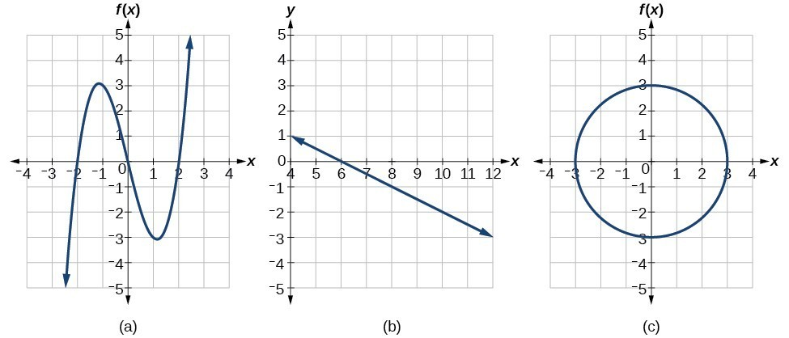

- What is the range of the relation represented by the coordinates (-8,9) (-4,6) (0,3) (4,0) (8, -3)?
- {-8, -4, 0, 4, 8}
- {-8, -4, -3, 0, 3, 4, 6, 8, 9}
- {0, 3, 4, 6, 8, 9}
- {{-3, 0, 3, 6, 9}
Evaluating Functions
- Which point lies on the line defined by 3x + 6y = 2?
- (0,2)
- (0,6)
- (1,- $\frac{1}{6}$)
- (1, - $\frac{1}{2}$)
- Which point lies on the line defined by y – 4 = 2(x – 3)?
- (2,8)
- (0,2)
- (1,8)
- (1,0)
- Which point lies on the line defined by y = - $\frac{3}{2}$x – 10
- (2,-7)
- (0,10)
- (6,1)
- (4,-16)
Forms of Linear Equations
Review Slope and y-intercept and how to identify
- The altitude of a plane above sea level, in feet, m minutes after departure is 293 + 500m.
Which statement is correct?
- The plane’s altitude decreases by 500 feet each minute after departure.
- The plane’s altitude increases by 500 feet each minute after departure
- The plane’s altitude increases by 293 feet each minute after departure
- The plane’s altitude decreases by 293 feet each minute after departure
- Which of the following situations represent a linear relationship?
- A train travels 45 miles per hour after departing the station
- The value of a car is decreasing by 7 percent a year
- The area covered by a circular area rug depends on the radius of each rug
- The number of bacteria in a lab experiment triples every hour
- Which of the following situations represent a linear relationship?
- A radioactive substance loses half its mass every twelve years
- The cost of living increases in a certain area by 3 percent per year
- The volume of a cubical gift box depends on the side length of a box
- Someone is losing 5 lbs. a month on her diet
- In a linear equation the independent variable increases at a constant rate while the dependent variable decreases at a constant rate. The slope of this line is
- zero
- negative
- positive
- undefined
Interpreting Graphs
Graphing using y =mx + b
- What coordinate would lie on the line x = 5?
- (5,1)
- (0,5)
- (-5,-5)
- (0,0)

- What coordinate would lie on the line y = 0?
- (-1,-1)
- (0,5)
- (1,1)
- (0,0)
x- and y-intercepts
- What is the x-intercept of the graph 5x + 2y = 10?
- 5
- 2
- -5
- -2
- What is the y-intercept of the graph of 4x + 2y = 12?
- - 4
- - 2
- 6
- 12
- What is the x- and y-intercepts –x + 2y = 8.
- x- intercept: -11 y-intercept: 4
- x- intercept: -11 y-intercept: 3
- x- intercept: -8 y-intercept: 3
- x- intercept: -8 y-intercept: 4
Introduce Standard and Point Slope form
(practicing manipulation)
Writing equations in 3 linear forms
- When you solve y = $\frac{x}{4}$ – 6 for x, which equation is the result?
- x = 4y + 24
- x = 4y - 24
- x = 4y +6
- x = 4y - 6
- When you solve 5x – 3y = 9 for y, which equation is the result?
- y = 5x -3
- y = $\frac{5}{3}$ x + 3
- y = $\frac{5}{3}$ x – 3
- y = - $\frac{5}{3}$ x + 3

- When arrange the linear equation y – 5 = $\frac{1}{2}$ (x - 6) into standard form, what is the result?
- –x + 2y = 4
- x – 2y = - 4
- x + 2y = - 4
- – x – 2y = 4
Writing Linear Equations:
Given slope and y-intercept
- A line with a slope of zero has y-intercept of 3. Write an equation in slope-intercept form.
- y = 3x +0
- x =3
- y =3
- x = 0
- A line with no slope does not have a y–intercept. Which equation could fit this description?
- y = 5
- 5y = 0
- 3x = 3
- y = x
Given a point and a slope
- A line with a slope of $\frac{1}{2}$ passes through (-5,-4). Write the linear equation in point-slope form.
- y + 4 = $\frac{1}{2}$(x+5)
- x – 2y = 3
- y = $\frac{1}{2}$x - $\frac{3}{2}$
- x + 2y = 9
- What is the equation of the line that has a slope of 4 and passes through the point (3,-10)?
- y = 4x – 22
- y = 4x + 22
- y = 4x – 43
- y = 4x + 43
- What is the slope of a line that passes through the points (-6, 1) and (4, -4)?
- -2
- 2
- - $\frac{1}{2}$
- $\frac{1}{2}$

- Write an equation in slope-intercept form for the line that passes through (3,7) and (7,4).
- y = - $\frac{3}{4}$ x + $\frac{37}{4}$
- y = - $\frac{4}{3}$ x + $\frac{37}{4}$
- y = $\frac{3}{4}$ x + $\frac{37}{4}$
- y = $\frac{4}{3}$ x + $\frac{37}{4}$
From graph
- Which equation describes the graph given?
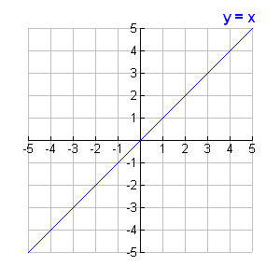

- y = x
- y = 0
- x = 0
- y = x +1

- Which equation describes the graph given below?
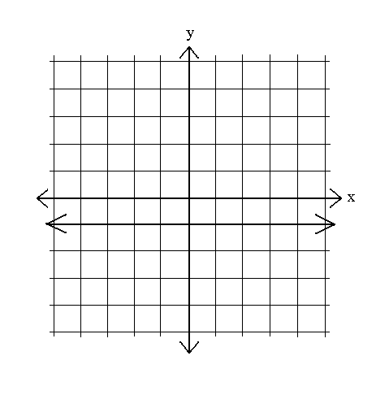

- y = x + 1
- y = 1
- x = 1
- y = x
- Which equation describes the graph given below?
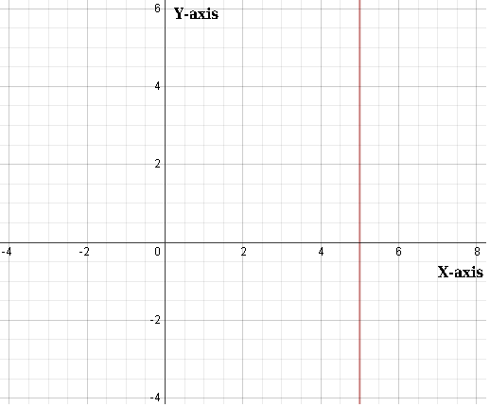
- y = 5x
- x = 0
- x = 5
- y = x + 5
From Table
- Create a linear equation given the table of values.
x | -1 | 0 | 1 | 2
y | 5 | 5 | 5 | 5
- y = 5x -1
- y = 5
- x = 5
- y = x + 5
- Create a linear equation given the table of values.
x | -1 | 0 | 1 | 2
y | 2 | 4 | 6 | 8
- y = 2x + 4
- y = 2x
- x = 2
- y = x - 2
- Create a linear equation given the table of values.
x | 1 | 3 | 5 | 9
y | 3 | 7 | 11 | 19
- y = 2x - 4
- y = 2x + 1
- x = 2
- y = 2x – 1
Parallel and Perpendicular Lines
- Which equation represents a line that is parallel to y = - $\frac{5}{4}$x + 2?
- y = - $\frac{5}{4}$x + 1
- y = - $\frac{4}{5}$ x+ 2
- y = $\frac{4}{5}$ x+ 3
- y = $\frac{5}{4}$ x+ 4
- Which equation represents a line that is perpendicular to the line y = - 4x +5
- y = -4x + 3
- y = - $\frac{1}{4}$ + 5
- y = $\frac{1}{4}$x +3
- y = 4x + 5
- The equation of line l is 6x +5y = 3, and the equation of the line q is 5x -6y =0. Which statement about the two lines is true?
- Lines l an q have the same y-intercept
- Lines l and q are parallel
- Lines l and q have the same x-intercept
- Lines l and q are perpendicular
- Which statement best describe the following linear equations.
3x – 4y = 10
y – 4 = $\frac{3}{4}$ (x+4)
- Lines are the same
- Lines are parallel
- Lines have the same y-intercept
- Lines are perpendicular
- Which statement best describe the following linear equations.
x = 5
y = -4
- Lines have the same x – intercept
- Lines are parallel
- Lines have the same y-intercept
- Lines are perpendicular
- The equation of the line l is y - 1 = 2(x-3) and the equation q is y – 3 = $\frac{1}{2}$(x-16). Which statement about the two lines is true?
- Lines l and q have the same y –intercept
- Lines l and q are parallel
- Lines l and q have the same x-intercept
- Lines l and q are perpendicular
From word problems
- A trucker traveled 500 miles in h hours. If the trucker averaged 60 mph, which linear equation could be used to find the number of hours the trucker drove?
A. 500 = 60 + h
B. 500 = 60 – h
C. 500 = 60h
D. 500 = $\frac{600}{h}$

- A store sold $325 of strawberries and blueberries. It sold x pints of strawberries and y pints of blueberries. The store charges $3 per pint for strawberries and $5 per pint for blueberries. Which equation represents the relationship among pints of strawberries, pints of blueberries, and the total amount of money?
- 3x + 5y = 325
- 5x + 3y = 325
- 8(x + y) = 325
- 4(x + y) = 325

- Mr. Turner bought x number of pencils. Each box holds 25 pencils. He left 3 boxes of pencils at home and took the rest to school. Which expression represents the total number of pencils he took to school?
- 22x
- 25x – 3
- 25 – 3x
- 25x – 75
- John rented a moving truck. The total rental cost included a one-time fee of $40.00 and $0.75 for each mile driven. Which equation represents, t, the total cost in dollars of renting a truck that was driven n miles?
- t = 40 + .75n
- t = 40 + $\frac{.75}{n}$
- t = .75 + 40n
- t = .75 + $\frac{40}{n}$
Take linear equation and information and use it to answer additional questions and understand what they mean
- The cost to rent a construction crane is $750 per day plus $250 per hour for use. What is the maximum number of hours the crane can be used each day if the rental is not to exceed $2500 per day?
- 2.5
- 7.0
- 5.5
- 7.5
- The total cost c in dollars of renting a sailboat for n days is given by the equation, c = 120 + 60n. If the total cost was $360, for how many days was the sailboat rented?
- 2
- 4
- 6
- 8

- Using the data plotted on the scatter plot, which equation most closely describes a line of best fit for the data?

- y = x + 6
- y = 2x – 4
- y = 2x + 5
- y = 3x – 4

Open-Ended Response:
The table shows the amount of water y in a tank after x minutes have elapsed
x(minutes) | 2 | 4 | 6 | 8
y(gallons) | 80 | 60 | 40 | 20

- Write an equation to find the amount of water (y) in gallons after a given number of minutes(x).

- Is water entering or leaving the tank?

- How much water is in the tank after 3 minutes

- Fin the slope and interpret its meaning.

- Find the x-intercept and y-intercept and interpret their meaning.

