Unit 3
Data Analysis and Probability
- Independent and Dependent events
- Compound events
- Circle Graphs and Bar Graphs
- Line Graphs and Scatter Plots
- Box-and-Whisker and Stem-and-Leaf

Standards Covered
A1.2.3 Data Analysis
A1.2.3.1 Use measures of dispersion to describe a set of data
A1.2.3.1.1 Calculate and/or interpret the range, quartiles, and interquartile range of data.
A1.2.3.2 Use data displays in in problem-solving settings and /or to make predictions.
A1.2.3.2.1 Estimate or calculate to make predictions based on a circle, line, bar graph,
measures of central tendency, or other representations
A1.2.3.2.2 Analyze data, make predictions, and/or answer questions based on displayed data
(box-and-whisker plots, stem-and-leaf plots, scatter plots, measures of central tendency, or other representations)
A1.2.3.2.3 Make predictions using the equations of graphs of best-fit lines of scatter plots
A1.2.3.3 Apply probability to practical situations
A1.2.3.2.1 Find probabilities for compound events (e.g., find probability of red and blue, find
probability of red or blue) and represent as a fraction, decimal, or percent
Keystone Practice Set

Independent and Dependent Events
- There are four red marbles, two green marbles, and six blue marbles in a bag. What is the probability of choosing a red then a blue with replacement?
- $\frac{1}{6}$
- $\frac{1}{2}$
- $\frac{2}{3}$
- $\frac{1}{3}$
- Consider a standard deck of cards. What is P(queen, king) with replacement?
- $\frac{1}{13}$
- $\frac{2}{13}$
- $\frac{1}{169}$
- $\frac{1}{26}$

- There are three blue marbles, two green marbles, and one brown marble. What is the P(blue, brown) without replacement?
- $\frac{1}{6}$
- $\frac{1}{2}$
- $\frac{2}{3}$
- $\frac{1}{3}$
Determine if the following situations are independent or dependent, and then determine the probability
- Amanda picks a card at random, puts it back, and then picks another card at random. What is the probability that she chooses a five and then a seven?
8
7
6
5
3

- Independent; $\frac{1}{25}$
- Independent; $\frac{5}{7}$
- Dependent; $\frac{1}{25}$
- Dependent; $\frac{5}{7}$

- There are four red marbles, two green marbles and six blue marbles in a bag. If Mason picks a marble at random, doesn’t replace it, and chooses another marble, what is the probability that he chooses a red marble and then another red marble?
- Independent; $\frac{1}{11}$
- Independent; $\frac{1}{9}$
- Dependent; $\frac{1}{11}$
- Dependent; $\frac{1}{9}$

- A bag has five red tiles, three blue tiles, seven green tiles and two yellow tiles.
- If one tile is selected at random, what is the probability that it is yellow? Express your answer as a fraction, a decimal, and a percent.

- If one tile is selected at random, what is the probability that it is green or red? Express your answer as a fraction.

- One tile is selected at random and then replaced. A second tile is selected at random. What is the probability that the first is blue and the second is green? Express your answer as a fraction. Show your work.

Compound Events
- You roll a number cube and flip a coin, how many outcomes are possible?
- 6
- 8
- 12
- 24
- You flip two coins and roll a number cube. How many outcomes are possible?
- 6
- 8
- 12
- 24
- What is the probability of tossing a number cube and spinning the spinner below and getting a sum of 7 or greater? Express the answer as a percent.
2
- 7%
- 11%
3
1
- 33%
- 54%
- One card is picked at random from a standard deck of playing cards. What is the probability that the card’s suit is diamonds or spades? Express the answer as a decimal.
- 0.096
- 0.250
- 0.500
- 0.019
- A Penny is tossed, a number cube is rolled, and a quarter is tossed. What is the probability that the penny lands on heads, the number cube shows an even number, and the quarter lands on tails? Express the probability as a decimal.
- 0.5
- 0.167
- 0.125
- 0.2

Circle Graphs and Bar Graphs
Use the circle graph for the next two questions
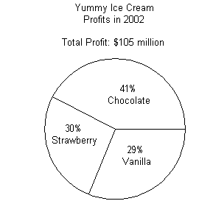
- Approximately how much of the profit was from sales of Vanilla ice cream?
- $43 million
- $31.5 million
- $75 million
- $30 million
- In 2004, the total profits for Yummy Ice Cream was $117 million. Assuming the same percentages estimate how much of the profit was from sales of strawberry ice cream.
- $82 million
- $48 million
- $35 million
- $34 million

Use the Bar Graph for the next 3 questions
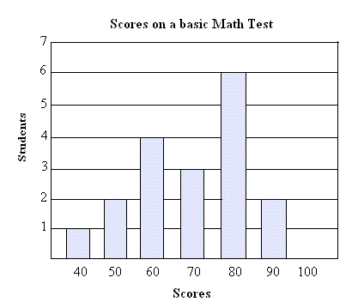
- Approximately how many student scored and 80% or higher on the Math Test?
- 6
- 8
- 10
- 16
- Based on these data, estimate the number of students who will score a 70% of the next 20 students to take the test.
- 3 students
- 5 students
- 7 students
- 9 students
- What is the average score on the Math Test?
- 60%
- 65%
- 70%
- 85%

Line Graphs and Scatter Plots
Use the scatter plot for the next 3 questions
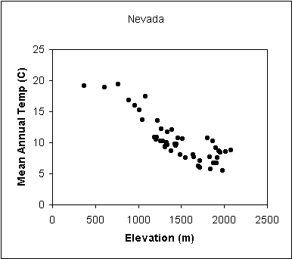
- Which describes the correlation between the elevation and the mean annual temperature in Nevada?
- Strong positive
- Strong negative
- Negative
- No correlation
- Which describes the relationship between the elevation and the mean annual temperature in Nevada?
- Elevation increases, annual temperature increases
- Elevation increases, annual temperature decreases
- Elevation decreases, annual temperature increases
- Elevation decreases, annual temperature decreases
- Estimate what the mean annual temperature is in Nevada at an elevation of 3000 meters.
- 5 degrees
- 0 degrees
- -10 degrees
- -20 degrees
Use the line graph for questions 4-5
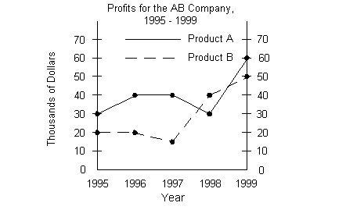
- What is the difference in profits between Product A and Product B in 1998?
- $10,000
- $10
- $20,000
- -$10,000
- For how many years was Product A’s profit more than Product B’s profit?
- 1
- 2
- 3
- 4

Box-and-Whisker Plots and Stem-and-Leaf Plots
Use the Box-and-Whisker Plot for the next 3 questions
The box and whisker plot below represents the part time hours worked by employees at the local Dollar Mart.

10 12 14 16 18 20 22 24
- What is the median number of hours worked by the part-time staff at Dollar Mart?
- 12
- 18
- 22
- 14
- What is the range of the number of hours worked by the part-time staff at Dollar Mart?
- 5
- 11
- 12
- 14
- What is the interquartile range of the number of hours worked by the part-time staff at Dollar Mart?
- 5
- 6
- 11
- 14

Use the Stem and Leaf Plots for the next 2 questions
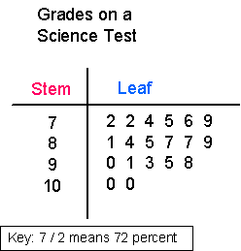
- What is the range of the test scores on the science test?
- 3
- 28
- 30
- 928
- What is the mode?
- 72 , 87
- 87, 100
- 72, 87, 100
- No mode

- The box-and whisker plot below displays the test scores of student sin Mrs. Dunmire’s class.
Scores on math test

50 55 60 65 70 75 80 85 90 95 100
- What is the median of the scores on the test?

- What is the best estimate for the range of scores on the test? Explain your reasoning.

- Calculate the interquartile range.
- Using the data below, create a box-and-whisker plot. Identify the five number summary. Then explain how each data point is determined.
22 17 25 24 8 6 30 36 42 10

